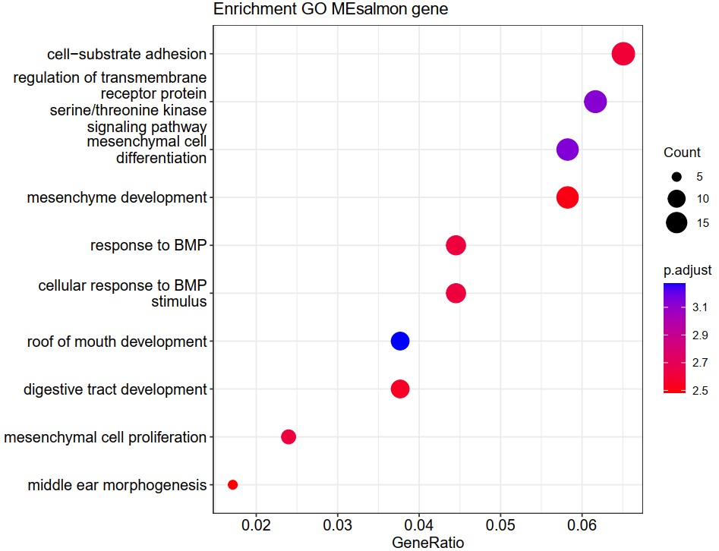

**Supplementary fig. 1** GO enrichment of salmon module.

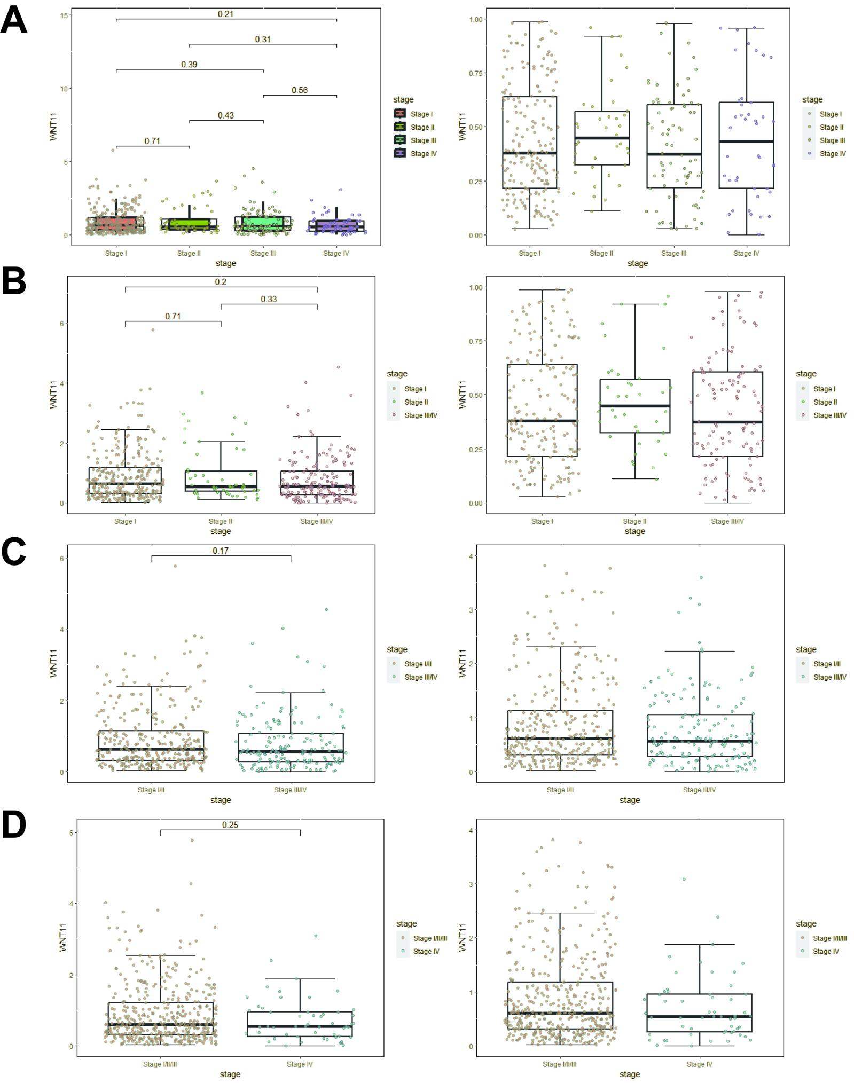

**Supplementary fig. 2** Comparison of WNT11 expression among separated ways of clinical staging of thyroid cancer in TCGA independent (A), stage III and IV merged (B) stage I/II merged and III/IV merged (C), stage I/II/III merged.

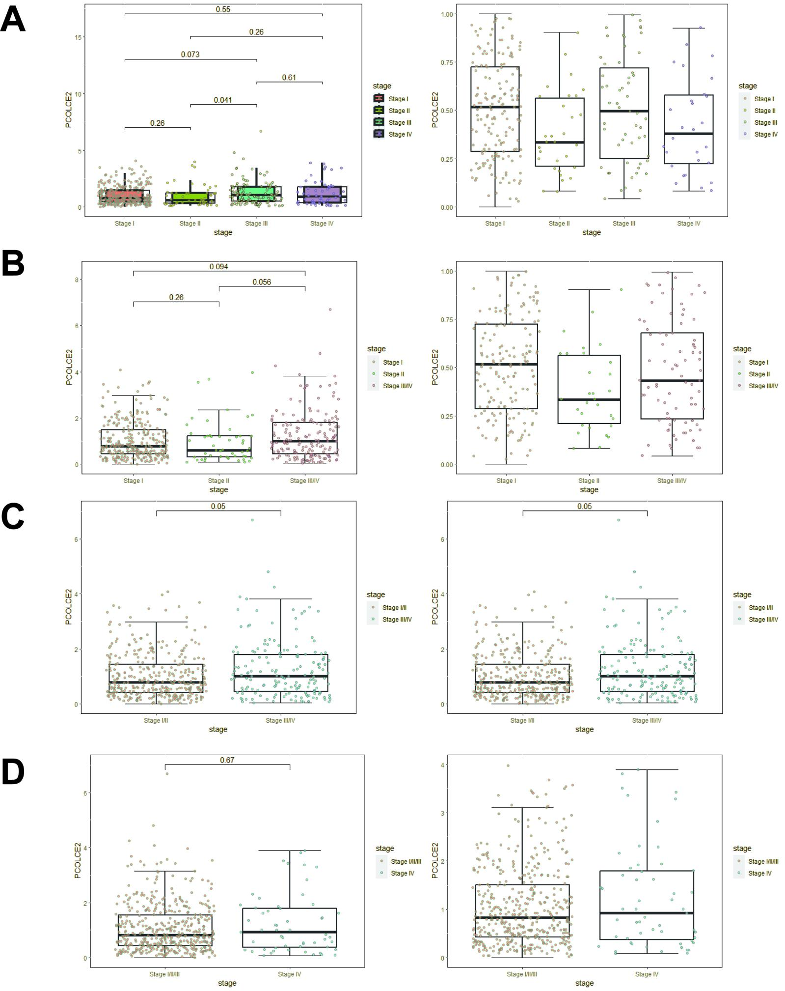

**Supplementary fig. 3** Comparison of PCOLCE2 expression among separated ways of clinical staging of thyroid cancer in TCGA independent (A), stage III and IV merged (B) stage I/II merged and III/IV merged (C), stage I/II/III merged.

**Supplementary table 1 Candidate genes of module salmon and darkgreen**

|  |  |
| --- | --- |
| **Module salmon**  **n=36** | **Module darkgreen**  **n=38** |
| SCARA5 | TOP2A |
| **SPSB4** | PBK |
| FGF10 | BIRC5 |
| SOX10 | CDC20 |
| RELN | KCNK10 |
| MYOC | KRT6C |
| F10 | UBE2C |
| ALDH1A2 | HLA-DRB5 |
| AOX1 | TPX2 |
| HSPB6 | POLQ |
| COLEC12 | TRAF5 |
| DACH2 | PLK1 |
| **WNT11** | TMEM154 |
| ADH1B | ESCO2 |
| MMRN1 | HLA-DQA1 |
| TNXB | CCNB2 |
| FMN2 | SERPINB3 |
| THPO | CKAP2L |
| **PCOLCE2** | OR2T2 |
| CRYM | CDC25C |
| SFRP1 | SHCBP1 |
| AKR1C1 | NCAPH |
| CHRDL1 | PLA2G2A |
| CFD | OR2T10 |
| FLNC | CDCA2 |
| RASSF10 | NCAPG |
| PODN | TOX2 |
| SNTG2 | ELL3 |
| DES | CENPK |
| CLDN5 | FAM83D |
| FBLN1 | NUSAP1 |
| SMOC1 | STEAP1B |
| LYVE1 | TROAP |
| OGN | MKI67 |
| IGF1 | RUBCNL |
| POTEC | AMTN |
|  | FOXM1 |
|  | NEIL3 |